Advanced Engineering Mathematics, by Erwin Kreyszig 10th. Ed.

**Problem Set 1.4**

No. 1

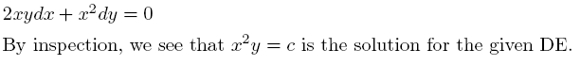

No. 2

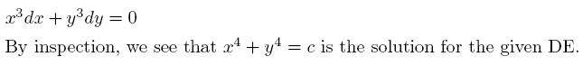

No. 3

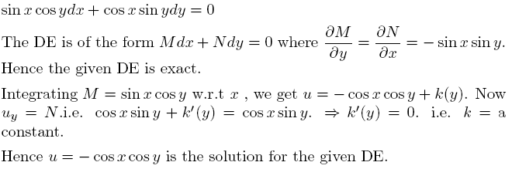

No. 4

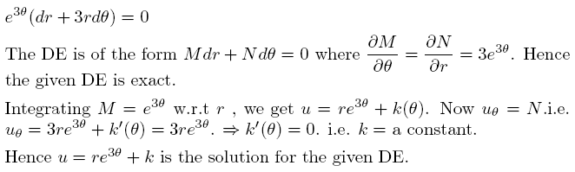

No. 5

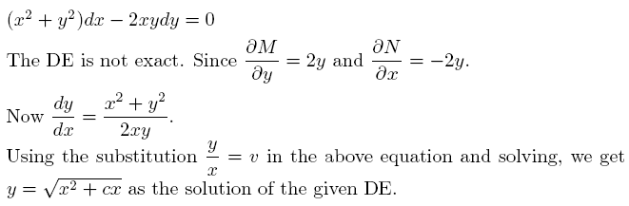

No. 6

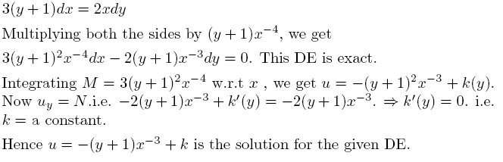

No. 7

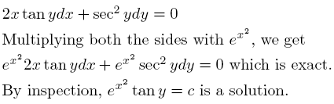

No. 8

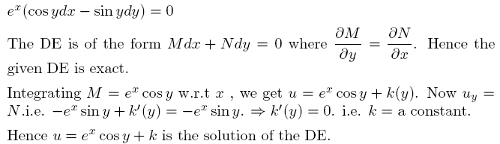

No. 9

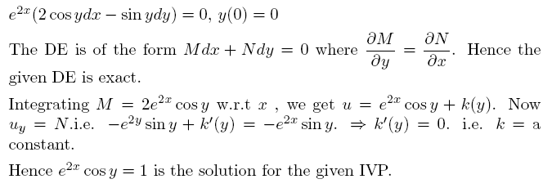

No.10

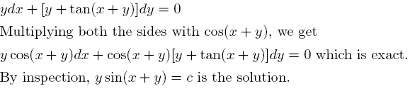

No.11

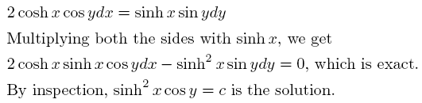

No.12

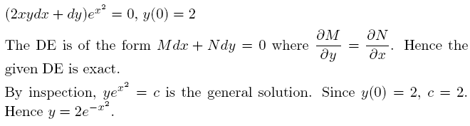

No.13

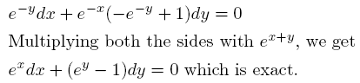

No.14

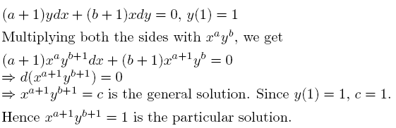

No.15

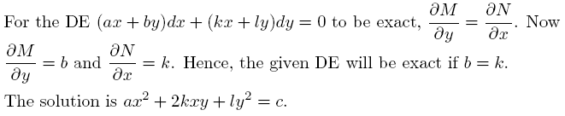

No.16

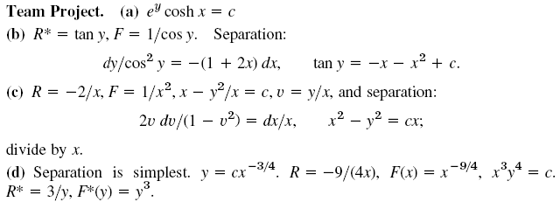

No.17

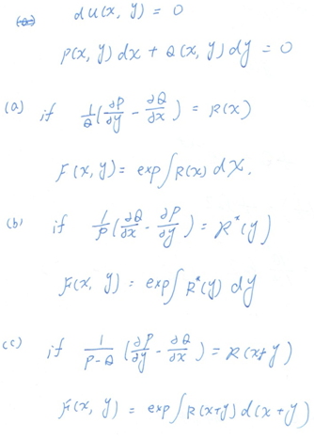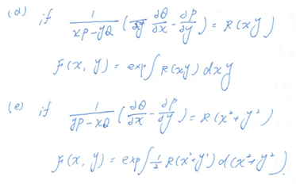

No.18

